Brief Schdedule

5th National Data Science Summit 2026

Theme: AI in Entrepreneurship
📅 Date: Sunday, 12th July 2026
📍 Venue: Daffodil Smart City, Birulia, Savar, Dhaka

International Conference Hall (ICH)

Main Summit Program
Time | Activity
8:00 – 9:15 AM | Registration & Guest Reception
10:00 – 10:20 AM | Opening ceremony & welcome Address by the Organizing Committee
10:20 – 10:30 AM | Address by the Head, Department of Software Engineering, DIU
10:30 – 10:40 AM | Address by the Pro Vice Chancellor
10:40 – 10:50 AM | Address by the Dean, FSIT
10:50 – 11:20 AM | Official Group Photo Session
11:20 AM – 1:00 PM | Industry Guests Visit Competition Venues & Evaluation Sessions
1:00 – 2:00 PM | Lunch Break
2:00 – 2:45 PM | (All competition evaluation wraps up — see competition tables)
2:35 PM | Participants Assemble in the ICH
2:45 – 3:00 PM | Industry Talk – Sakhawat Hossain: Becoming an Industry-Ready Software Engineer
3:00 – 3:15 PM | Industry Talk – Sayed Refat Al Abrar: Building Software for Global Companies
3:15 – 3:30 PM | Industry Talk – Abdullah Al Hasan: Building a Startup from Bangladesh
3:30 – 3:50 PM | Closing Keynote – Mohammad Mizanur Rahman (CTO, Brain Station 23): The Future of AI Careers & Building AI Products at Scale
3:50 – 4:15 PM | Sponsor Recognition & Guest Appreciation Ceremony
4:15 – 4:45 PM | Award Ceremony & Certificate Distribution
4:45-5:00 PM | Networking, Group Photos & Guest Departure

Data Hackathon

Venue
- Data Science Lab (601)
- CSC Laboratory
- Robotics Laboratory (Participants with personal laptops)

Judges
Judges (industry): Sayed Refat Al Abrar
Judges (academic): Dr. Abdus Sattar · Afsana Begum · Dr. Ashikur Rahman
Time | Activity
11:00 AM – 2:30 PM | Data Hackathon
11:20 AM – 1:00 PM | Evaluation
2:35 PM | Participants proceed to the ICH
4:15 – 4:45 PM | Award Ceremony

Project Showcase Competition

Venue
Student Lounge

External Judge
Judges (industry): Mohammad Mizanur Rahman
Judges (academic): Dr. Shaikh Muhammad Allayear · Md. Khaled Sohe
Time | Activity
8:30 – 9:00 AM | Registration & Orientation
11:00 – 2:00 PM | Project Demonstrations
12:30 – 1:00 PM | Jury Discussion
1:00 – 2:00 PM | Lunch Break
2:00 – 2:30 PM | Jury Discussion
2:35 PM | Participants proceed to the ICH
4:15 – 4:45 PM | Award Ceremony

Promptcraft Challenge

Venue
- Lab 710
- Lab 711A
- Lab 711B
- Lab 814B

Judges
Judges (industry): Mohammad Mizanur Rahman
Judges (academic): Dr. Shaikh Muhammad Allayear · Md. Khaled Sohel
Time | Activity
12:30 PM – 1:30 PM | Promptcraft Challenge
2:10 PM | Participants proceed to ICH
1:45 – 2:45 PM | Evaluation (Department of Software Engineering Office)
4:15 – 4:45 PM | Award Ceremony

Research Poster Presentation

Venue
Student Lounge

Judges
Judges (industry): Sakhawat Hossain
Judges (academic): Dr. S. M. Hasan Mahmud · Dr. Kamrul Islam Shahin · Dr. Nusrat Jahan · Dr. Fernaz Narin Nur
Time | Activity
11:00 AM – 1:00 PM | Poster Presentation (live session)
11:30 AM – 1:00 PM | Evaluation (all judges, during the session)
2:20 PM | Participants proceed to the ICH
4:15 – 4:45 PM | Award Ceremony

Hands-on Workshop

Venue
Prof. Dr. Aminul Islam Seminar Hall
Time | Activity
11:30 AM – 12:30 PM | Hands-on Workshop by Sumit Saha

Overall Event Flow
Venue | Time
International Conference Hall (ICH) | 8:00 AM – 4:45 PM
Student Lounge (Project Showcase Competition) | 8:30 AM – 2:30 PM
Student Lounge (Research Poster Presentation) | 11:00 AM – 1:00 PM
Data Hackathon Venues (Data Science Lab, CSC Lab & Robotics Lab) | 11:00 AM – 2:30 PM
Prof. Dr. Aminul Islam Seminar Hall (Workshop) | 11:30 AM –12:30 PM
Promptcraft Labs (710, 711A, 711B & 814B) | 12:30 – 1:30 PM

Guest/Judges



5th National Data Science Summit 2026

AI in Entrepreneurship
Guest & Judges

Name | Designation | Role In Summit | Time | Activity | Venue
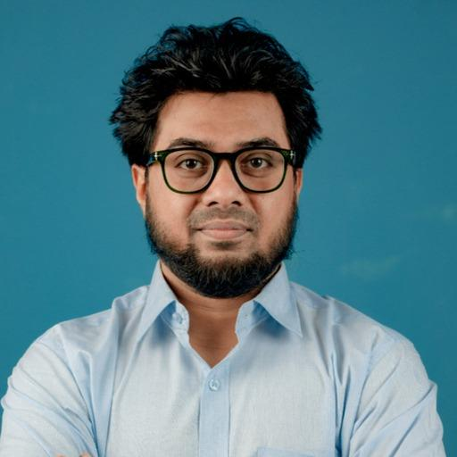  Syed Refat Al Abrar  refat.abrar@cefalo.com | Staff Software Engineer  Remote Dev Team Specialist  Technical Consultant  Cefalo | - External Judge – Data Hackathon  - Industry Speaker | 8:30 – 11:20 AM | Opening Ceremony & Official Group Photo | International Conference Hall (Level 3)
 |  |  | 11:20 AM – 1:00 PM | Visit & Judge Data Hackathon | Data Science Lab (601)  CSC Lab (Level 6)  Robotics Lab (Level 6)  Computer lab 609
 |  |  | 1:00 – 2:00 PM | Lunch (Green Garden)
 |  |  | 2:00 – 2:30 PM | Data Hackathon Evaluation | Data Science Lab (601)  CSC Lab (Level 6)  Robotics Lab (Level 6)  Computer Lab 609
 |  |  | 3:00 – 3:15 PM | Industry Talk: Building Software for Global Companies (ICH) | International Conference Hall (Level 3)
 |  |  | 3:55 – 4:35 PM | Awards & Closing Ceremony(ICH) | International Conference Hall (Level 3)
 |  |  | 4:35 – 4:45 PM | Networking | International Conference Hall (Level 3)
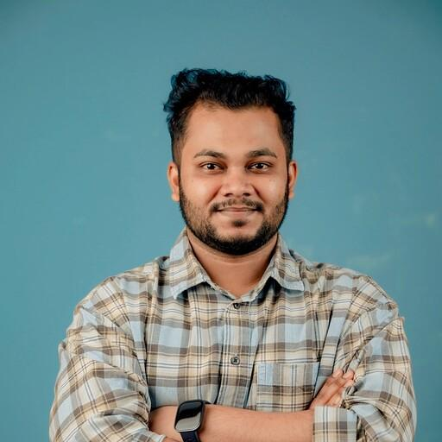  Sakhawat Hossain  sakhawat.hossain@cefalo.com | Senior Software Engineer II at Cefalo  Ex - BS23 | - External Judge – Research Poster Presentation  - Industry & Alumni Speaker | 8:30 – 11:20 AM | Opening Ceremony & Official Group Photo | International Conference Hall (Level 3)
 |  |  | 11:30 AM – 1:00 PM | Judge Research Poster Presentation | Student Lounge
 |  |  | 1:00 – 2:00 PM | Lunch (Green Garden)
 |  |  | 2:45 – 3:00 PM | Industry Talk: Becoming an Industry-Ready Software Engineer | International Conference Hall (Level 3)
 |  |  | 3:55 – 4:35 PM | Awards & Closing Ceremony | International Conference Hall (Level 3)
 |  |  | 4:35 – 4:45 PM | Networking | International Conference Hall (Level 3)
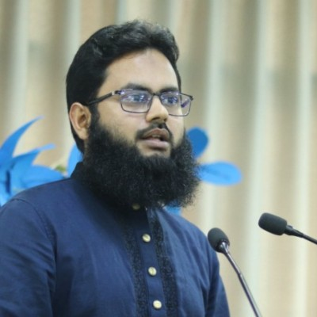  Abdullah Al Hasan  hasan.cse91@gmail.com | Founder & CEO, Muslims Day  Ex - BS23 | - External Judge – Project Showcase Competition  - Industry Speaker | 8:30 – 11:20 AM | Opening Ceremony & Official Group Photo | International Conference Hall (Level 3)
 |  |  | 11:20 AM – 12:30 PM | Visit Competition Venues & Interact with Participants | Data Science Lab (601)  CSC Lab (Level 6)  Robotics Lab (Level 6)  Student Lounge
 |  |  | 12:30 PM – 1:30 PM | External Judges Evaluation Project Showcase | Student Lounge
 |  |  | 1:30 – 2:00 PM | Lunch (Green Garden)
 |  |  | 2:00 – 3:00 PM | External Judges Evaluation Project Showcase | Student Lounge
 |  |  | 3:15 – 3:30 PM | Industry Talk: Building a Startup from Bangladesh | International Conference Hall (Level 3)
 |  |  | 3:55 – 4:35 PM | Awards & Closing Ceremony | International Conference Hall (Level 3)
 |  |  | 4:35 – 4:45 PM | Networking | International Conference Hall (Level 3)
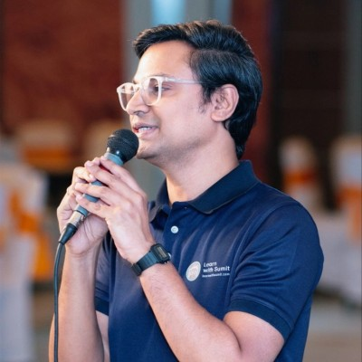  Sumit Saha  sumit@learnwithsumit.com | Founder & CEO, Analyzen  Founder, Learn with Sumit  Co-founder, logicBase Labs | - Hands-on Workshop Instructor  - External Judge – Project Showcase Competition  - Participant Interaction & Networking | 8:30 – 11:20 AM | Opening Ceremony & Official Group Photo (Optional) | International Conference Hall (Level 3)
 |  |  | 11:30 AM – 12:30 PM | Hands-on Workshop: Modern AI-Assisted Development with JavaScript (Topic can be updated) | Prof. Dr. Aminul Islam Seminar Hall (Level 6)
 |  |  | 12:30 – 1:30 PM | External Judges Evaluation Project Showcase | Student Lounge
 |  |  | 1:30 – 2:00 PM | Lunch (Green Garden)
 |  |  | 2:00 – 3:00 PM | External Judges Evaluation Project Showcase | Student Lounge
 |  |  | 3:55 – 4:35 PM | Awards & Closing Ceremony | International Conference Hall (Level 3)
 |  |  | 4:35 – 4:45 PM | Networking | International Conference Hall (Level 3)
  Dr. S. M. Hasan Mahmud  drhasan.swe@diu.edu.bd | Associate Professor  Department of Software Engineering  Daffodil International University | - Guest Academia & Judge | 11:30 AM – 1:00 PM | Session Chair & Judge– Research Poster Presentation | Student Lounge
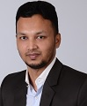  Dr. Kamrul Islam Shahin  drshahin.swe@diu.edu.bd | Associate Professor  Department of Software Engineering  Daffodil International University | - Guest Academia & Judge | 11:30 AM – 1:00 PM | Session Chair & Judge – Research Poster Presentation | Student Lounge
  Dr. Nusrat Jahan  headitm@daffodilvarsity.edu.bd | Associate Professor and Head  Department of Information Technology & Management (ITM)  Daffodil International University | - Guest Academia & Judge | 11:30 AM – 1:00 PM | Judge – Research Poster Presentation | Student Lounge
  Dr. Fernaz Narin Nur  fernaz.cse@diu.edu.bd | Professor, CSE  Daffodil International University | - Guest Academia & Judge | 11:30 AM – 1:00 PM | Judge – Research Poster Presentation | Student Lounge
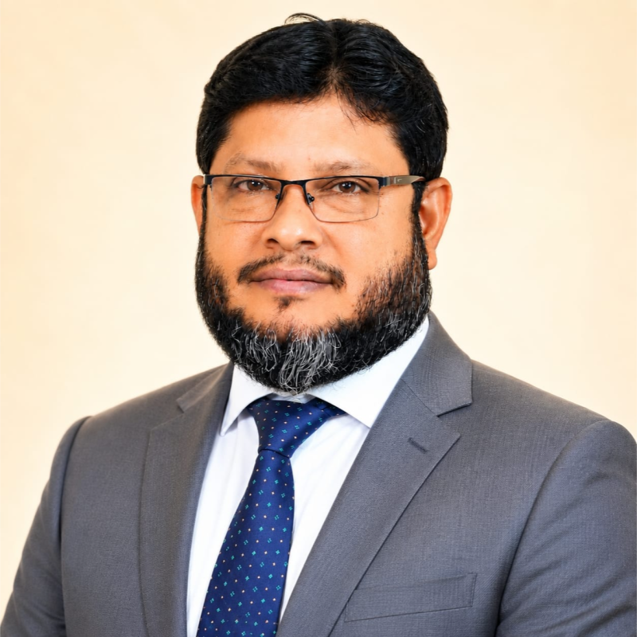  Dr. Abdus Sattar  abdus.cse@diu.edu.bd | Associate Professor & Director, M.Sc in CSE  Daffodil International University | - Guest Academia & Judge | 11:20 AM – 1:00 PM | Judge – Data Hackathon | Data Science Lab (601)  CSC Lab (Level 6)  Robotics Lab (Level 6)  609
  Afsana Begum  afsana.swe@diu.edu.bd | Assistant Professor & Coordinator M.Sc  Department of Software Engineering  Daffodil International University | - Guest Academia & Judge | 11:20 AM – 1:00 PM | Judge – Data Hackathon | Data Science Lab (601)  CSC Lab (Level 6)  Robotics Lab (Level 6)  609
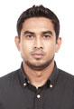  Dr. Ashikur Rahman  ashikur.itm@diu.edu.bd | Assistant Professor  Department of Information Technology & Management (ITM)  Daffodil International University | - Guest Academia & Judge | 11:20 AM – 1:00 PM | Judge – Data Hackathon | Data Science Lab (601)  CSC Lab (Level 6)  Robotics Lab (Level 6)
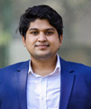  Mr. Mayen Uddin Mojumdar  mayen.cse@diu.edu.bd | Assistant Professor  Department of Computer Science and Engineering  Daffodil International University | - Guest Academia & Judge | 12:30 PM – 3:00 PM | Judge – Project Showcase Competition | Student Lounge
  Mr. Md. Kamruzzaman  headde@daffodilvarsity.edu.bd | Assistant Professor and Head  Department of Innovation & Entrepreneurship  Daffodil International University | - Guest Academia & Judge | 12:30 PM – 3:00 PM | Judge – Project Showcase Competition | Student Lounge
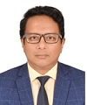  Dr. Rubaiyat Islam  islam.swe@diu.edu.bd | Associate Professor  Department of Software Engineering  Daffodil International University | - Guest Academia & Judge | 12:30 PM – 3:00 PM | Judge – Project Showcase Competition | Student Lounge
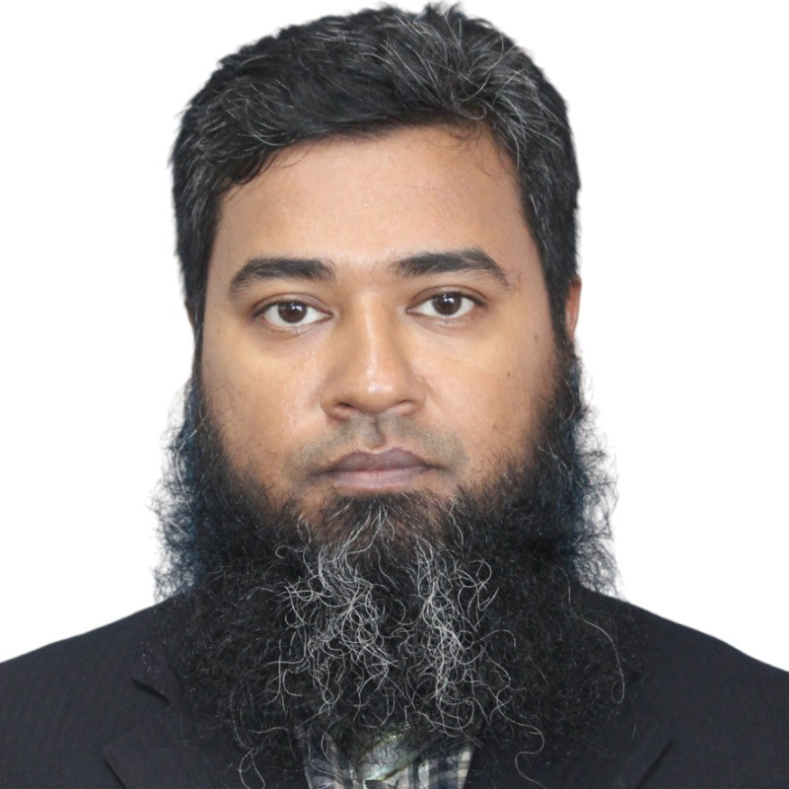  Dr. Md. Abdul Kader  abdulkader.swe@diu.edu.bd | Associate Professor  Department of Software Engineering  Daffodil International University | - Guest Academia & Judge | 12:30 PM – 3:00 PM | Judge – Project Showcase Competition | Student Lounge
  Dr. Shaikh Muhammad Allayear  drallayear.mct@diu.edu.bd | Professor & Proctor  Department of Multimedia & Creative Technology (MCT)  Daffodil International University | - Guest Academia & Judge | 12:30 PM –2:45 PM | Judge – Promptcraft Challenge | Lab 710  Lab 711A  Lab 711B  Lab 616  Final Evaluation SWE exam office
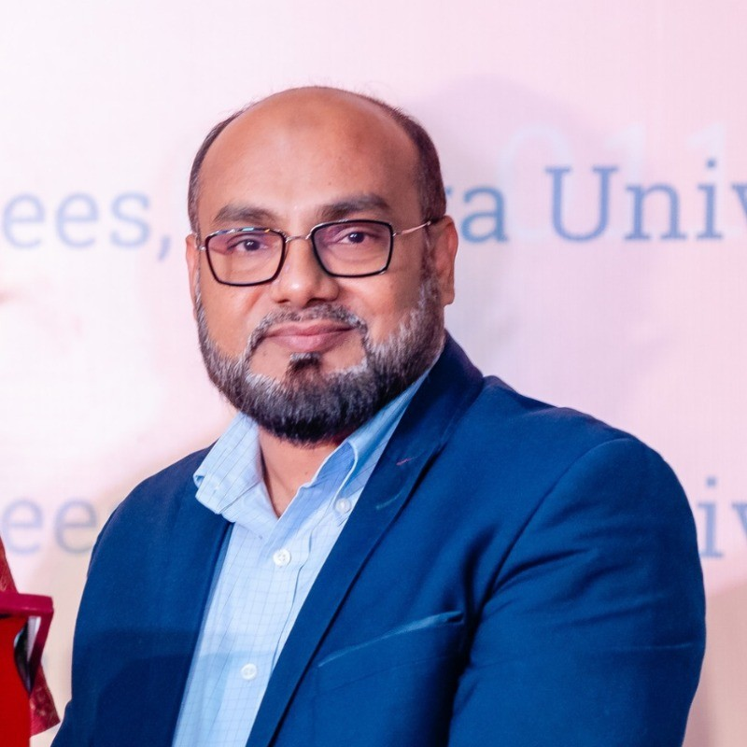  Prof. Dr. A. H. M. Saifullah Sadi  sadi.swe@diu.edu.bd | Professor & Director, M.Sc in Cyber Security  Department of Software Engineering  Daffodil International University | - Guest Academia & Judge | 12:30 PM –2:45 PM | Judge - Prompt Craft Challenge | Lab 710  Lab 711A  Lab 711B  Lab 616  Final Evaluation SWE exam office
  Mr. Md. Khaled Sohel  khaledsohel@daffodilvarsity.edu.bd | Assistant Professor  Department of Software Engineering  Daffodil International University | - Guest Academia & Judge | 12:30 PM –2:45 PM | Judge – Promptcraft Challenge | Lab 710  Lab 711A  Lab 711B  Lab 616  Final Evaluation SWE exam office

5th Data Science Summit 2026
5th National Data Science Summit 2026
Sunday, 12th July 2026

Event | Faculty | Contact
Coordination, Management & Distribution | Md. Shariar Parvez | 01944829693
 | Fahad Hossain | 01946704373
 | Faruk Ahmed | 01611193974
 | Jul Jalal Al-Mamur Sayor | 01787054914
 | Student Volunteers

Event | Faculty | Contact
Project Showcasing  Venue: Student Lounge  Time: 11:45 AM - 02:00 PM | Mahbubur Rahman | 01797368331
 | Md. Rashedul Alam | 01771087871
 | Arif Faisal | 01723465155
 | Rahat Uddin Azad | 01878517664
 | MS. SYEDA SUMAIA SULTANA | 01864646749
 | Student Volunteers

Event | Faculty | Contact
Hackathon  Venue: 601(DS Lab), 614 (CS Lab), 609, 613  Time: 11:45 AM - 2:30 PM | Fahad Hossain | 01946704373
 | Rahat Uddin Azad | 01878517664
 | S. M. SAIDUR RAHMAN | 01324194133
 | Izaz Ahmed Tuhin
 | Md. Rashedul Alam | 01771087871
 | Naomi Afrin Jalil | 01783691167
 | Maria Afrin Bindu | 01617374700
 | Khalid Masum | 01533519531
 | Student Volunteers

Event | Faculty | Contact
Poster Presentation  Venue: Student Lounge  Time: 11:45 AM - 01:30 PM | MR. BIBHAS ROY CHOWDHURY PIYAS | 01703428672
 | MS. FATAMA JANNAT TISHA | 01881638899
 | Jafrin Iqbal Chowdhury | 01842208940
 | Md. Rashedul Alam | 01771087871
 | Student Volunteers

Event | Faculty | Contact
Prompt Video Making  Venue: 710, 711A, 711B, 616  Time: 12:45 PM - 2:00 PM | MD. MAZBAUR RASHID | 01796228391
 | MS. FATAMA JANNAT TISHA | 01881638899
 | Syed Shams Islam | 01704427800
 | Tasnim Rahman | 01317796537
 | Student Volunteers

Event | Faculty | Contact
Hands on Workshop  Venue: Aminul Islam Hall  Time: 12:00 AM - 1:30 PM | MS. SHAHRIN ISLAM | 01779448961
 | MS. FATAMA JANNAT TISHA | 01881638899
 | Student Volunteers

Closing - Everyone

